MY IBD MARINE CAMP EXPERIENCE, Danjugan Island

Cheryl C. Awacay
Mun. Planning and Development Office,
Municipality of San Enrique, Negros Occiddidental

-Excerpts-

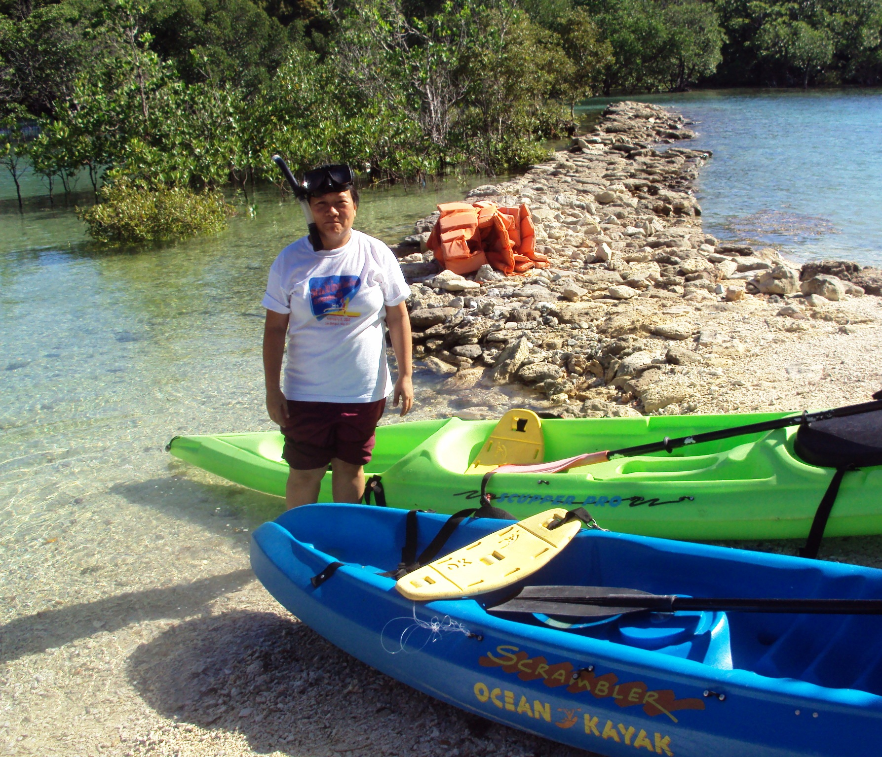
It was Wednesday noon, May 12, 2010 when I was invited to the Marine Camp sponsored by the German Technical Cooperation (GTZ) at Danjugan Island, Cauayan, Negros Occidental, Actually this was not my first camping because I attended so many camps during my teenage years. Those were religious and youth camping. The marine camp is different and rarely conducted. This is a once in a lifetime activity because it involves training, learning on bio diversity and does not end because the participants commit to advocate after.

We traveled for almost three (3) hours to Cauayan and fifteen minutes boat ride to the island. When we reached Danjugan, we saw people waiting for us, the German Technical Cooperation (GTZ) the German Technical Service (DED), PEMO and PPDO staff, and the crew of the island who are maintaining and managing the place. When I saw the place my excitement started and eager to discover what is in the island. Lunch was served after which we brought our things to our respective cottages. After a while, the opening program started and we were oriented about the two (2) day activity. The topic was all about Biodiversity relative to the International Biodiversity Day (IBD) celebration. We set our expectations for the two day camp. Everyone participated and those expectations were discussed. Stefan from DED, gave a short quiz pre evaluation test. We gave wrong and right answers but he said, “Its okay we will just see if your answers are correct tomorrow”. Various lectures were given through slide shows of marine life like the different mangrove species, sea grasses their functions and importance. We were able to understand their uses, their role in the ecosystem and why it is imperative to protect and conserve them. We were also taught how to measure and identify mangrove species growing because we ourselves actually went to the area. After some additional inputs while we were doing the activity, we went around the island and explore other beautiful marine life which is abundant in the place. We have seen plenty and various corals in different shapes and sizes. We found out that the place is rich with marine resources that we thought we cannot find them here anymore. We went back to our cottages tired, and slept deeply filled with joy seeing those wonderful creatures made by God.

The following day, we woke up to the sound of the humming birds in the forest and excited of the day’s activities. I felt refreshed when I looked around. The wonderful nature, the sound of the waves, the wind that blows, and the trees around us. I can’t imagine that I was in an island with so much to discover and to reflect the greatness of our creator . The abundance of marine life like the corals, sea grasses, fishes and the presence of birds, trees and other animals gave life to the island and makes it a paradise.

The first activity was bird watching. We went to the area silently so the birds won’t be disturbed. We have seen a hole where Tabon birds (Scrub fowls) lay their eggs. Birds of different species live in the island. From there, we proceeded to the cave where python snakes and bats can be seen. Many of us hesitated to see but there were also some who were curious how they look like. We passed a forest area and saw the snake on their siesta hour. From there, we climbed 500 meters in going to the watch tower. We were all perspiring and very tired upon reaching the top but it was a great feeling. We climbed the top of it and view the scenery around the island. After some photo documentations we returned to our training camp and ate our breakfast. After a little rest, we prepared our gadgets for the snorkeling and study of sea grasses. Slide shows and lectures were provided about sea grasses. Everyone was excited and eager to swim due to the heat of the sun and how to undergo the steps on sea grasses identification.

We went to the other side of the island and did the next activity. Everybody enjoyed dipping and getting samples of sea grasses together with Momo (DED), Stefan (DED) and Julie Ann (GTZ). After the morning activities, remaining lectures were given and we reviewed the quiz given by Stefan yesterday. This time we were confident of our answers because of the learning that we had. After all, what’s the use of attending when you have learned nothing.

The last activity that we had was the preparation of Operation Plan by municipality. Plans and programs for the management of coastal resources how to sustain them and make them available at all times. Each participant gave his share and requested to do the reporting by Local Government Unit. A closing program then followed where we made evaluations of the two (2) day activities. There were good impressions but there were also negative ones nevertheless, we have learned so much. Our participation to the marine camp gave us new learning imperatives on our role as stewards of these God –given resources, for us to manage properly and develop not only for the benefit of the present generation but also for our children’s children so that what we have now, will be enjoyed by them.

The marine camp was ideal not only for nature-lovers, but also meant for everybody to be aware and advocate its importance to humans. It was also a training ground on how to handle difficulties, inconveniences and in preparation for harder and tougher situations.



